SRM INSTITUTE OF SCIENCE AND TECHNOLOGY

(Established under section 3 of UGC Act 1956)

# **ACTIVITY PREDICTION OF THE ELDERLY**

A MINOR PROJECT REPORT

#### Submitted by

SWARNIMA GUPTA [Reg No: RA1911028010032]

MANAN MATHUR [Reg No: RA1911029010089]

#### Under the Guidance of

## MRS. G. PARIMALA

(Assistant Professor, Department)

### *in partial fulfillment of the requirements for the degree of*

## BACHELOR OF TECHNOLOGY

## in

## COMPUTER SCIENCE ENGINEERING

## with specialization in CLOUD COMPUTING & COMPUTER NETWORKING

## DEPARTMENT OF NETWORKING AND COMMUNICATIONS COLLEGE OF ENGINEERING AND TECHNOLOGY

SRM INSTITUTE OF SCIENCE AND TECHNOLOGY

## KATTANKULATHUR- 603 203

### NOVEMBER 2022

Department of Networking and Communications

##### SRM Institute of Science & Technology

##### Own Work* Declaration Form

This sheet must be filled in (each box ticked to show that the condition has been met). It must be signed and dated along with your student registration number and included with all assignments you submit – work will not be marked unless this is done.

To be completed by the student for all assessments

##### Degree/ Course : COMPUTER SCIENCE ENGINEERING WITH SPECIALIZATION IN CLOUD COMPUTING AND COMPUTER NETWORKING

**Student Name :** SWARNIMA GUPTA, MANAN MATHUR

##### Registration Number : RA1911028010032, RA1911029010089

**Title of Work :** ACTIVITY PREDICTION OF THE ELDERLY

We hereby certify that this assessment compiles with the University’s Rules and Regulations relating to Academic misconduct and plagiarism**, as listed in the University Website, Regulations, and the Education Committee guidelines.

We confirm that all the work contained in this assessment is our own except where indicated, and that We have met the following conditions:

* Clearly references / listed all sources as appropriate
* Referenced and put in inverted commas all quoted text (from books, web, etc)
* Given the sources of all pictures, data etc. that are not my own
* Not made any use of the report(s) or essay(s) of any other student(s) either past or present
* Acknowledged in appropriate places any help that I have received from others (e.g. fellow students, technicians, statisticians, external sources)
* Compiled with any other plagiarism criteria specified in the Course handbook / University website

We understand that any false claim for this work will be penalized in accordance with the University policies and regulations.

|  |
| --- |
| **DECLARATION:** |
| We are aware of and understand the University’s policy on Academic misconduct and plagiarism and we certify that this assessment is our own work, except where indicated by referring, and that we have followed the good academic practices noted above. |
| If you are working in a group, please write your registration numbers and sign with the date for every student in your group. |



# SRM INSTITUTE OF SCIENCE AND TECHNOLOGY KATTANKULATHUR – 603 203

## BONAFIDE CERTIFICATE

Certified that this B.Tech project report titled “**ACTIVITY PREDICTION OF THE ELDERLY”** is the bonafide work of **Ms. SWARNIMA GUPTA and Mr. MANAN MATHUR** who carried out the project work under our supervision. Certified further, that to the best of my knowledge the work reported herein does not form part of any other thesis or dissertation on the basis of which a degree or award was conferred on an earlier occasion for this or any other candidate.

<<Signature >> <<Signature >> <<Signature >>

**SIGNATURE SIGNATURE SIGNATURE**

##### MRS. G. PARIMALA <<Name >> DR. ANNAPURANI PANAIYAPPAN .K

|  |  |  |
| --- | --- | --- |
| **SUPERVISOR**  [Assistant Professor]  [Department] | **CO-SUPERVISOR**  [Designation]  [Department] | **HEAD OF THE DEPARTMENT**  Networking and Communications |

ACKNOWLEDGEMENTS

We express our humble gratitude to **Dr C. Muthamizhchelvan**, Vice-Chancellor, SRM Institute of Science and Technology, for the facilities extended for the project work and his continued support. We extend our sincere thanks to Dean-CET, SRM Institute of Science and Technology, **Dr T.V.Gopal**, for his valuable support.

We wish to thank **Dr Revathi Venkataraman**, Professor & Chairperson, School of Computing, SRM Institute of Science and Technology, for her support throughout the project work. We are incredibly grateful to our Head of the Department**, Dr. Annapurani Panaiyappan.K**Professor, Department of Networking and Communications, SRM Institute of Science and Technology, for her suggestions and encouragement at all the stages of the project work.

We want to convey our thanks to our program coordinators [**Program coordinator name],**[Designation], and Panel Head, [**Panel head name],**[Designation], Department of Networking and Communications, SRM Institute of Science and Technology, for their inputs during the project reviews and support. We register our immeasurable thanks to our Faculty Advisor**, Mr. K. SenthilKumar, Dr. V. Pandimurugan**, SRM Institute of Science and Technology, for leading and helping us to complete our course.

Our inexpressible respect and thanks to our guide, **Mrs. G. Parimala,**Assistant Professor, [Department], SRM Institute of Science and Technology, for providing us with an opportunity to pursue our project under her mentorship. She provided us with the freedom and support to explore the research topics of our interest. Her passion for solving problems and making a difference in the world has always been inspiring.

We sincerely thank the Networking and Communications Department staff and students, SRM Institute of Science and Technology, for their help during our project. Finally, we would like to thank parents, family members, and friends for their unconditional love, constant support, and encouragement.

SWARNIMA GUPTA

MANAN MATHUR

**ABSTRACT**

Health care is very important for any human being. With modern time, the need of health care services for elderly people is increasing day by day. The family members of the elderly people have poor work-life balance and rising workloads create a necessity for improved and advanced technology. In many developing countries, senior citizens often live alone and are responsible for managing their own jobs. A product has to be created in order to assure the wellbeing of their physical and mental health using smart gadgets and developing technology. The service requires accurate predictions of their body health using sensors from their smartphones to measure their daily life activities. The product is a web application that tracks movements of the elderly using sensors and then monitors their actions using Artificial Intelligence and Machine Learning techniques such as Decision Tree Classifiers and Logistic Regressors. The project introduces a machine learning-based fall detector as well as a multi-agent architecture for contacting emergency assistance via an input sensor from the web-based monitoring application. Our product estimates to have an accuracy of 0.99 using Decision Tree whereas 0.69 was the accuracy of the model using ANN (taken from the base paper). Due to these techniques, accurate data can be calculated and verified.

**TABLE OF CONTENTS**

|  |  |  |  |
| --- | --- | --- | --- |
| CHAPTER NO. | | TITLE | PAGE NO. |
| ABSTRACT | |  | 5 |
| 1. | INTRODUCTION | | 7-8 |
|  | 1.1 GENERAL | | 7 |
|  | 1.2 OBJECTIVES | | 7 |
|  | 1.2 PURPOSE | | 8 |
|  | 1.2.1 SCOPE | | 8 |
|  | 1.2.2 NEED FOR PREDICTION SYSTEM | | 8 |
| 2 | LITERATURE REVIEW | | 9 |
|  | 2.1 2022 PAPER | | 9 |
|  | 2.2 2021 PAPER | | 9 |
|  | 2.3 2020 PAPER | | 9 |
|  | 2.4 2019 PAPER | | 9 |
| 3 | DIAGRAMS | |  |
|  | 3.1 BLOCK DIAGRAM | | 10 |
|  | 3.2 ARCHITECTURE DIAGRAM | | 10 |
|  | 3.3 USE CASE DIAGRAM | | 11 |
|  | 3.4 ACTIVITY DIAGRAM | | 11 |
| 4 | EXPERIMENT | | 12 |
| 5 | ALGORITHMS USED  MODULES | | 13 |
| 6 | MODELS USED | | 14 |
| 7 | IMPLEMENTATION | | 15 |
| 8 | REFERENCES  PLAGIARISM REPORT | | 18 |
|  |  | |  |

**INTRODUCTION**

Our project “Activity Prediction of the Elderly” is a web-based application for a smart healthcare monitoring system. This application is made for the elderly people living alone in developing countries to predict their activity in their homes using sensors. In many developing countries, senior citizens often live alone and are responsible for managing their own jobs. With so many advancement in technology and a highly competitive work environment, the elderly’s self-sufficiency has become a source of concern. A product has to be created in order to assure the wellbeing of their physical and mental health using smart gadgets and developing technology. This application employs Artificial Intelligence and Machine Learning techniques such as Decision Tree Classifiers and Logistic Regressors.

**OBJECTIVES**

The objective of the project is to gain the insight about the activities of the elderly and to predict their movements that could be useful to them and is easily assessable as well as operable. Our project's objective is to gather information through wristbands connected to the mobile application that will determine how active a person is depending on the physical activities they engage in. The web application takes sensor readings from their smartphones to track hand and leg movements, as well as body temperature and predicts activity based on the sensor coordinates provided. The application project uses a machine learning-based fall detector and multi-agent architecture for contacting emergency assistance. We hope to develop a smart application to measure the daily activities of the elderly for their physical and mental well-being.

**PURPOSE**

The purpose of the project is to gain the insight about the activities of the elderly and to predict their movements that could be useful to them and is easily assessable as well as operable. This will be done using Artificial Intelligence and Machine Learning concepts like Decision Tree Classifiers and Logistics Regressors. On the basis of activity prediction, immediate action can be taken in the event of an emergency or if unusual pattern in their daily lives is discovered.

**SCOPE**

Elderly folks don't get the care they need because of rising workloads and a poor work-life balance of their family members. Therefore, intelligent technology is required to keep an eye on the actions and to give prompt assistance in the event of an emergency. The scope is to use a tri-axial accelerometer to detect falls and report such findings to an emergency centre. The application project uses a machine learning-based fall detector and multi-agent architecture for contacting emergency assistance.

**NEED**

In many developing countries, senior citizens often live alone and are responsible for managing their own jobs. With so many advancement in technology and a highly competitive work environment, the elderly’s self-sufficiency has become a source of concern. A product has to be created in order to assure the wellbeing of their physical and mental health using smart gadgets and developing technology.

**LITERATURE REVIEW**

|  |  |  |  |
| --- | --- | --- | --- |
| **TITLE** | **YEAR** | **ACHIEVEMENTS** | **LIMITATIONS/**  **SUGGESTIONS** |
| Activities Recognition, Anomaly Detection and Next Activity Prediction Based on Neural Networks in Smart Homes | 2022 | The proposed approach consists of three stages which are activity recognition, anomaly detection and next activity prediction. Such a system can provide useful information for the elderly, caregivers and medical teams to identify activities and generate preventive and corrective measures. | * A clean sequence of activities has been constructed by discarding the anomalous instances. * Future work needed to handle the imbalance dataset to improve the deep learning models. |
| Jointly Prediction of Activities, Locations, and Starting Times for Isolated Elderly People | 2021 | * This paper proposes a multi- task activity prediction system that jointly predicts labels, locations, and starting times of future activities. * Uses body activity information from wearable sensors and motion information from passive environmental sensors to sense activities of daily living of older adults. | These systems can provide better services to assist older people if it anticipates what activities inhabitants will perform ahead of time |
| Health status prediction for the elderly based on machine learning | 2020 | * The machine learning methods help researchers select the predictors of health status in the older population efficiently. * The artificial neural networks have the best prediction accuracy in relation to older people's self-reported health. | * Researchers are challenged with developing advanced techniques to examine the datasets as well as identifying the appropriateness to build a predictive model. |
| Fall Detection For elderly patients -DRT | 2019 | * Chosen Random Classifier with parameters like max_depth as 50 and n_estimators as 200 along with a threshold of 0.4 To be the best model not only because of the highest accuracy scores but also because it has the lowest false negative rate. | * The cost is comparatively low because the assumption is that companies prevalent already in the healthcare field will adopt this solution. |

**BLOCK DIAGRAM**

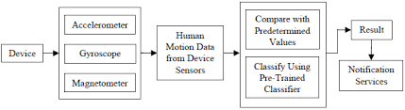

**ARCHITECTURE DIAGRAM**

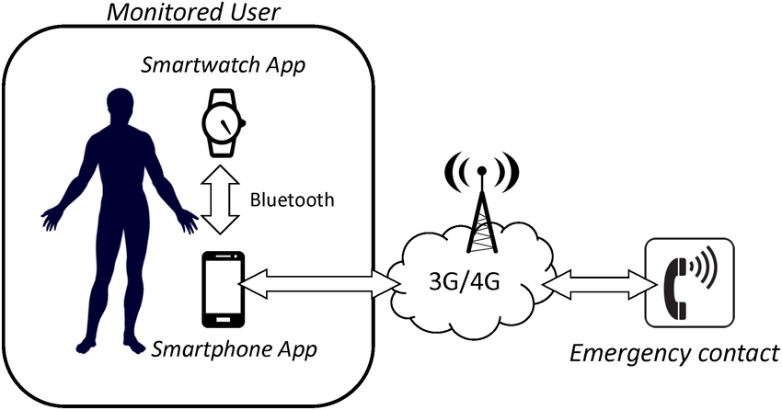

**USE CASE DIAGRAM OF THE SERVICE FOR MONITORING ACTIVITIES AND LOCATION OF USERS**

**ACTIVITY DIAGRAM**

**EXPERIMENT**

This experiment is mainly split up into the following sections:  
1. **Data Preview**. Take the original data set, import it into the database, and observe its data structure. Make the inference on the column and rows data present in the dataset.  
2. **Data Merge**. In the original dataset, the questionnaire for each topic is separate. It makes sense to merge them into a single dataset to simplify the analysis.  
3. **Feature selection**. Apply machine learning algorithms such as pre-processing models like Principal Component Analysis (PCA) to extract the factors that have the greatest impact on the health of older adults.  
4. **Data processing**. Process the data until you can use the data to train a machine learning model. This is done to calculate and manipulate the data provided into much desirable and useful form.

5. **Training model.** Train multiple machine learning models using the comparative training set. It’s the phase where practitioners try to fit the best combination of weights and bias to a machine learning algorithm to minimize a loss function over the prediction range.

6. **5-fold cross-validation**. The entire data set is randomly divided into 5 groups, one group is called the validation set, the rest are called the training set, and the validation is run 5 times using different algorithms to test accuracy.

7. **Result**. Get results and further summarize conclusions by different methods. One of them being Confusion matrix to guide the work.

**ALGORITHMS USED**

**MODULES**

1. Data Cleaning

2. Exploratory Data Analysis

3. Modelling

4. Dimensionality Reduction using Principal Component Analysis (PCA)

5. Logistic Regression

6. Decision Tree Classifier

**MODELS USED**

|  |  |
| --- | --- |
|  | matplotlib==3.4.1  numpy==1.20.1  pandas==1.3.2 |
|  | scikit_learn==1.0.2  streamlit==0.88.0 |
|  |  |

1. matplotlib==3.4.1

Matplotlib is a comprehensive library for creating static, animated, and interactive visualizations in Python.

2. numpy==1.20.1

NumPy is a Python library used for working with arrays. It also has functions for working in domain of linear algebra, fourier transform, and matrices.

3. Pandas==1.3.2

Pandas is an open source Python package that is most widely used for data science/data analysis and machine learning tasks.

4. scikit_learn==1.0.2

Scikit-learn is probably the most useful library for machine learning in Python. The sklearn library contains a lot of efficient tools for machine learning and statistical modeling including classification, regression, clustering and dimensionality reduction.

5. streamlit==0.88.0

Streamlit is an open source app framework in Python language. It helps us create web apps for data science and machine learning in a short time.

**IMPLEMENTATION**

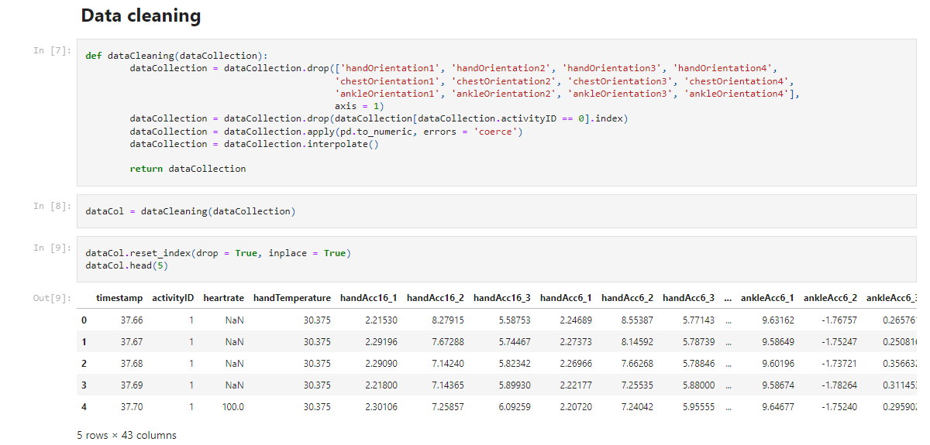

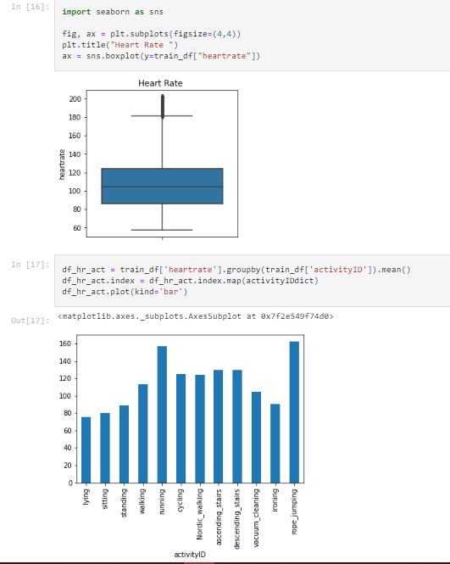

**REFERENCES**

1. <https://www.researchgate.net/publication/341571722_Health_status_prediction_for_the_elderly_based_on_machine_learning>
2. <https://www.kaggle.com/code/drtina/fall-detection-for-elderlypatients-drt#Present-your-solution>.
3. <https://ieeexplore.ieee.org/document/9729817>
4. <https://ieeexplore.ieee.org/document/9580533/keywords#keywords>
5. <https://ieeexplore.ieee.org/search/searchresult.jsp?newsearch=true&queryText=activity%20prediction%20of%20the%20elderly>

**PLAGIARISM REPORT**